NAME:G.SAI CHARAN
HALLTICKET:2403a51023
AICI

SET 2
Q1. (Data Structures – 5 Marks)
Using AI, create a Python implementation of a Binary Search Tree (BST) with:
- Insert
- Inorder traversal
- Search operation
Demonstrate all operations with sample input.
CODE:
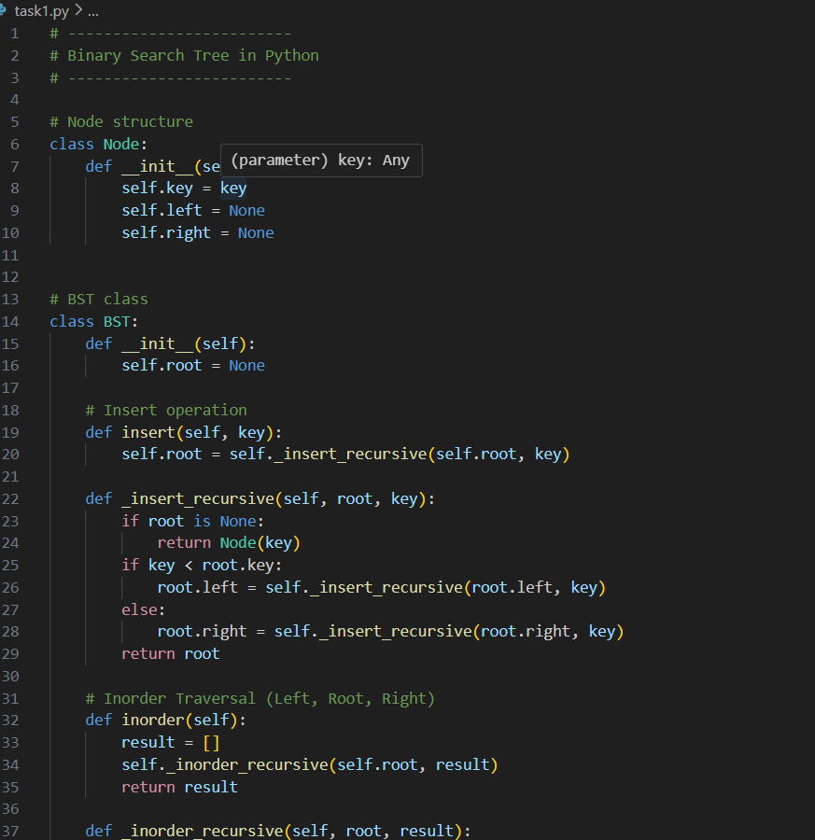

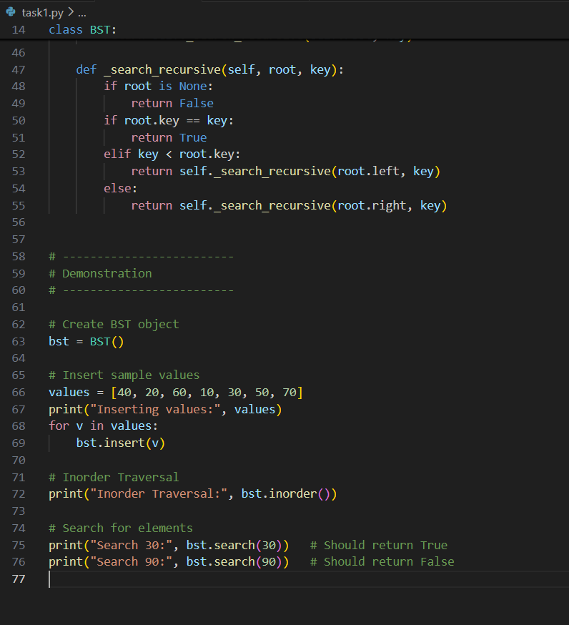

OUTPUT:

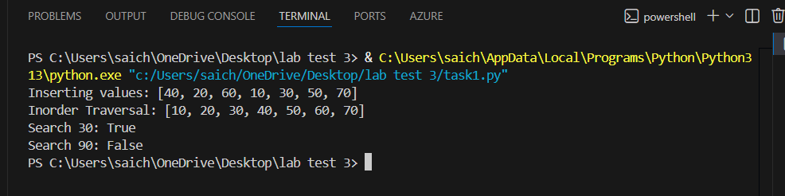

Q2. (Algorithms – 5 Marks)
Use AI to write Python code for Linear Search with early exit optimization.
Apply it on a list of 20 elements.
Display number of comparisons.

CODE:

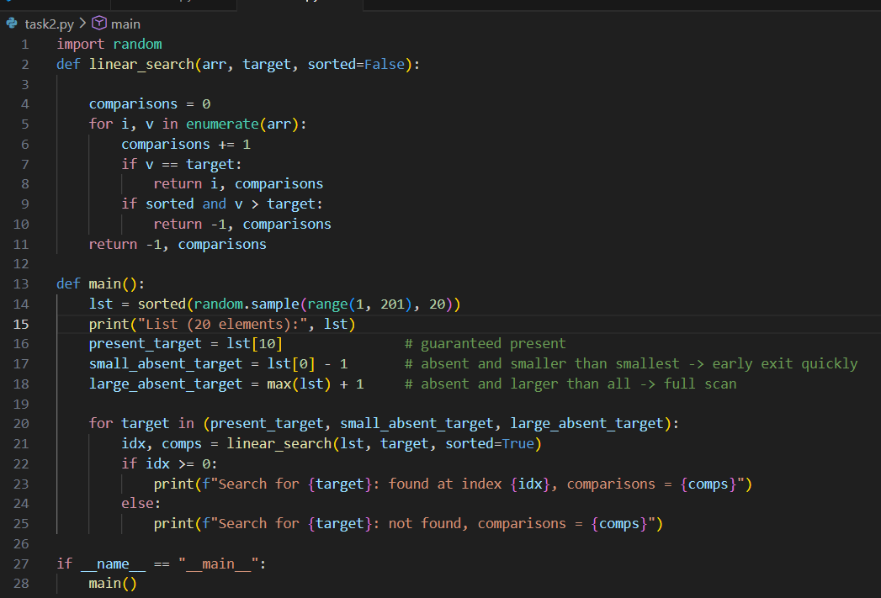

OUTPUT:
